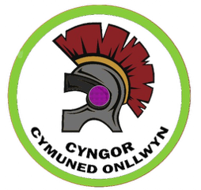
BANWEN CEMETERY.
FEES FROM 1st April 2025.

DESCRIPTION | PRICE
EXCLUSIVE RIGHT OF BURIAL (EROB*)  Burial plot  Cremation plot | £500  £300
Purchase of a new full burial plot (EROB and interment) | £800
Purchase of new cremation plot (EROB and interment) | £450
Extension of EROB | £200
Transfer of ownership of EROB | £20
Persons under the age of 18 (including stillborn and foetal remains) | No charge
BURIALS
Interment – Full burial | £300
Interment – Cremated remains | £150
Persons under the age of 18 (including stillborn and foetal remains) | No charge
OTHER CHARGES
Permit for the Erection of a Memorial Headstone | £100
Additional inscription on a Memorial Headstone | £35
Search of Burial Records | £10

Memorials are only permitted on plots where Exclusive Right of Burial has been purchased.

The fees for Exclusive Right of Burial and interment for Burial or Cremation plots will be reduced by 50% for residents currently residing within the Onllwyn Community Council ward area.

If you have any questions in relation to these prices please contact the Clerk on the details above.

