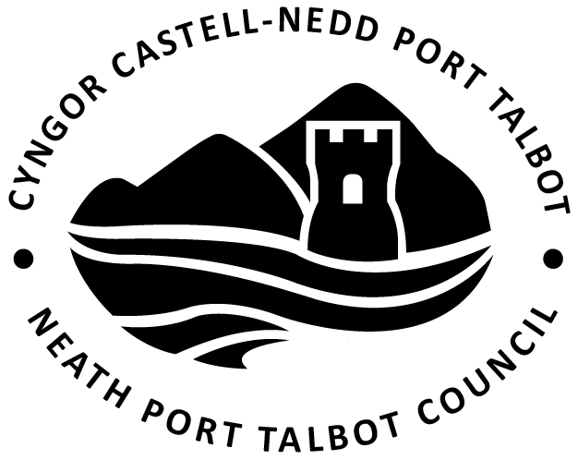


MAES GWYN ONLLWYN COMMUNITY BENEFIT FUND

APPLICATION FORM

Sections marked  contain advice to help you complete this form, you should also refer to the ‘Guidance Notes for Applicants’ document.

This Fund is only available to the community of Onllwyn.
1.1 Name of Organisation

1.2 Contact Address of Organisation

1.3 First Contact Person | Second Contact Person
Position | Position
Daytime Contact Phone No. | Daytime Contact Phone No.
Email Address | Email Address
The First Contact Person should be someone we can talk to if we have any questions about your project.
About Your Organisation
1.4 What does your organisation do? Please give as much detail as possible about what your organisation does including your aims and objectives and how it achieves them.

1.5 When did your organisation start?

1.6 Do you have a constitution or similar document?
(Please answer yes or no)
Do you have a Bank account in the name of the organisation
(Please answer yes of no)

A constitution is the governing document which says what your organisation does and where and how you achieve it. If you do not have a constitution or similar document you will not be able to apply for funding. If you have any queries please contact us.

1.7 Which of the following best describes your work/services? (Please indicate all which apply)

 | Recreational |  | Cultural
 | Educational |  | Services for children or young people
 | Health and Well Being |  | Services for Older People (50+)
 | Environmental |  | Work in disadvantaged communities
 | Energy Efficiency |  | Other (please state)………………………………………………

Your organisation’s finances
1.8 Please provide the following information

(a) Total income in the last financial year:

(b) Total amount spent in the last financial year:

(c) Current savings or unallocated funds:

If your organisation has over £5,000 in savings or unallocated funds, please tell us why:


You will need to submit a copy of your latest Audited Accounts with your Application Form. If your organisation is new or does not produce Audited Accounts, please send us a copy of your most recent Bank Statement.

Your organisation’s financial details
1.9 Please give us the details of your group’s bank account

Group Name on Account

Bank/Building Society name

Bank/Building Society address

Sort Code

Account No

Building Society roll number (If applicable)

Please give the names of two bank signatories and their positions in your organisation.
1 | Name |  | Position
2 | Name |  | Position

Your project‘s need for funding and how it meets the Fund Criteria
2.1 Please tell us about the project you want a grant for. Where will it be taking place?
Your answer should describe the activity you need a grant for and explain how the funding will help to deliver the project.

2.2 How have you identified the need for the project?
How do you know your project is really needed? Have you undertaken any consultation exercises (questionnaires, online surveys, etc)? Are there similar organisations to yours within the same area? If there are, you will need to tell us how what you do is different to them.

2.3 What genuine long term community benefits do you anticipate as a result of the grant?
What difference will your project make? Please tell us about the people who will benefit from it and how it will improve life in your local community.

2.4 How many people will benefit from this project?
We want to know how many people will be involved in the activities that the grant will fund. It is important to give us as much information as possible so we can assess your application properly.

2.5 Timescale of this project
Start date | Finish date | Or ongoing (please indicate)

2.6 How will the project be sustained after the investment of grant aid?
How will the project be continued after the grant money has been spent? Please explain how your project will be looked after and maintained.

2.7 How will you measure the progress and success of this project?
What will success look like and how do you intend to record it?

Project Costs
3.1 Please provide a breakdown of the total cost of this project excluding VAT
This is the cost of everything related to your project, even the items or activities you aren’t asking us to fund. Please provide accurate figures based on your quotes, and don’t round your figures up or down.
Item | £ Amount | Tick if you are applying for this item from the Maes Gwyn Community Fund
Total amount required for the whole project (without VAT) (A)
Total VAT for this project (B)

Total Project cost (A) + (B)

Is your Organisation registered for VAT and able to recover this element of the Project?
(Please answer yes or no)
If you answered ‘yes’ please provide VAT Registration Number

You will need to supply three quotations for all single items of equipment/ capital works over the value of £500.


We aren’t able to award funding for recoverable VAT.

3.2
How much money are you asking the Maes Gwyn Community Benefit Fund for? (please be aware that requests of over £15,000 require a 20% match funding contribution towards the total project cost) | £
How much have you raised elsewhere for this project? Please list funders and amounts below
 | £
 | £
 | £
Please list other funders you have applied to for this project but have not yet received approval, how much you have applied for, and when you will know if your application has been successful (if you have failed to attract match funding please list the sources you have explored and exhausted).
 | £
 | £
 | £

3.3 Referee
The referee must be a professional person or person of standing in the community. Examples include bank officials, police officers, ministers of religion and people with professional qualifications (teachers, accountants, solicitors etc) – NOT local councillors or other members of your organisation due to the potential conflict of interest.

Name

Relationship to your organisation

Address

Daytime Phone No
Email

3.4 Other Information – Please tell us about any other information you feel we should be aware of in order to strengthen your bid.

4.1 Where did you hear about this grant scheme?

4.2 If your grant is approved may we use your organisation as an example to promote our work? (Please answer yes or no)

Declaration
- I am authorised to make the Application on behalf of the Organisation.
- I certify that to the best of my knowledge the information contained in this Application is correct.
- If the information changes in any way I will inform the Grant Management Organisation of the Maes Gwyn Community Fund immediately.
- I further confirm that if successful, the Organisation agrees to the following conditions:
- Use the grant only for the purpose in the offer letter
- The invoices submitted under this Scheme have not been used to claim grant aid from other sources for the same expenditure
- Complete a Project Completion Report as requested
- Agree to take part in any publicity of the grant as required
- Not to use the funding for any projects that conflict or adversely affect the aim or policies of ‘Pennant Walters Ltd’ or any of its associated Companies or partners.

Name  (Block Capitals) |  | Position (Block Capitals)
Signed |  | Date

Checklist
Please enclose the following documents with your application or it may not be considered
A signed and dated Constitution (if you do not have a signed copy we will still require an unsigned copy together with a copy of the Minutes of the meeting at which it was adopted. If you do not have a constitution please contact us) Schools Exempt
Audited Accounts If you are a new organisation or if you do not produce Audited Accounts please provide a copy of your most recent bank statement (showing the account name and details) Schools Exempt
Three Quotations must be supplied for all single items of equipment and for all Capital items/Works over £500
Insurance Policy (Appropriate to the project, facility or activity to be developed)
Lease or Hire Agreement (Where applicable)

Please ensure you have answered every question as incomplete Application Forms may not be considered.
Please return your application via post or email to:
‘The Maes Gwyn Community Benefit Fund’
C/o The Clerk
Onllwyn Community Council

onllwyncommunitycouncil@gmail.com

