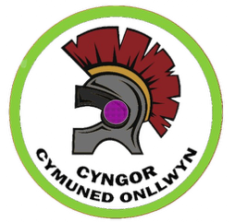**Application to pre-purchase the Exclusive Rights of Burial**

Email: [onllwyncommunitycouncil@gmail.com](mailto:onllwyncommunitycouncil@gmail.com)

Telephone: 07913775456

Cemetery: Dyffryn Cellwen 12 June 2025

Please specify in which section the grave space is to be allocated:

Consecrated

Unconsecrated

Cremation

(Please tick)

Period grant required for (maximum of 99 years) ______________ years

I understand and agree to comply with Onllwyn Community Council regulations.

|  |  |  |
| --- | --- | --- |
| Full name of purchaser | Applicants signature (digital accepted) | Date |
| Address of purchaser |  | Contact telephone number **and** email. |

Current fees are listed on the Community Council website.

Following application, the necessary forms will be sent to your email address to proceed, once this is complete you will receive your grant notification.

If completing the form in paper format, please return to Mr S Chaplin (Clerk) at 3 Heol y Waun, Seven Sisters, SA10 9BL